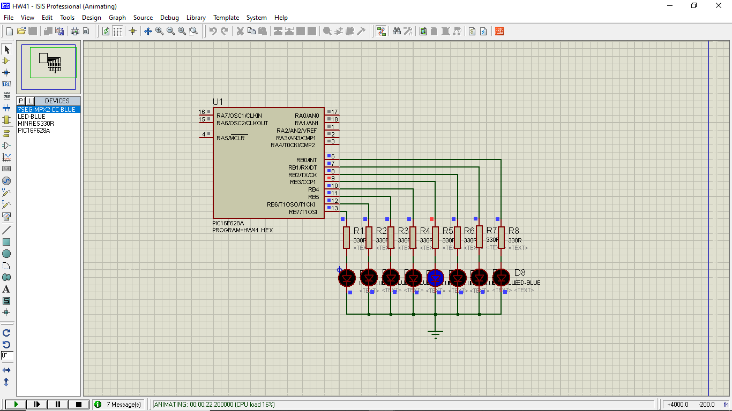;*******************************************

;HW41 ไฟวิ่งซ้ายไปขวา แล้วขวามาซ้าย

;*******************************************

PROCESSOR PIC16F628

#include <P16F628.INC>

__CONFIG _CP_OFF & _MCLRE_OFF & _HS_OSC & _LVP_OFF & _WDT_OFF

**cblock** 0x20

temp

count

count0

count1

count2

**endc**

ORG 0x00

;init

**movlw** .7

**banksel** CMCON

**movwf** CMCON ; Disable analog comparator

**banksel** TRISB

**movlw** 0x00

**movwf** TRISB ; Set PORTB as an output port

**banksel** PORTB

**clrf** PORTB

**clrf** temp

**bsf** temp,0

Infloop:

**movlw** .7

**movwf** count

LeftLoop:

**rlf** temp,f

;comf temp,w ; the run led off, the left leds on

**movf** temp,w ; the run lef on, the left leds off

**movwf** PORTB

**call** Delay500mS

**decfsz** count,f

**goto** LeftLoop

**movlw** .7

**movwf** count

RightLoop:

**rrf** temp,f

;comf temp,w ; the run led off, the left leds on

**movf** temp,w ; the run lef on, the left leds off

**movwf** PORTB

**call** Delay500mS

**decfsz** count,f

**goto** RightLoop

**goto** Infloop

DelaymS:

**movwf** count2

**incf** count2,f

**decfsz** count2,f

**goto** $+2

**goto** $+3

**call** Delay1mS

**goto** $-4

**return**

Delay1mS:

**movlw** .50 ; 1 cyc

**movwf** count1 ; 1 cyc

outterloop:

**movlw** .5 ; 1 cyc * count1

**nop** ; 1 cyc * count1

**movwf** count0 ; 1 cyc * count1

innerloop:

**decfsz** count0,F ; 1 cyc * count1 * count0

**goto** innerloop ; 2 cyc * count1 * count0

**decfsz** count1,F ; 1 cyc * count1

**goto** outterloop ; 2 cyc * count1

**return** ; 1 cyc

; total = 3 + (6+3.count0).count1

; count0 = 5 , count1 = 50, total = 1053 cyc ??

Delay500mS:

**movlw** .250;

**call** DelaymS;

**movlw** .250;

**call** DelaymS;

**return**

END

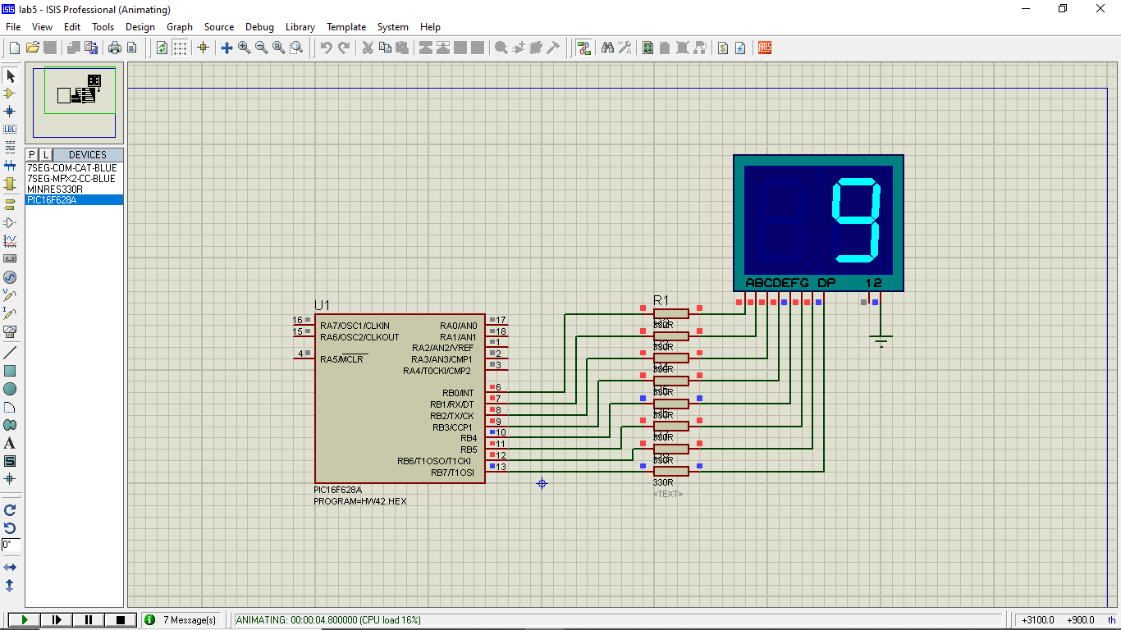

;*******************************************

;HW42 7sengment run 0 to 9 delay 500ms

;*******************************************

PROCESSOR PIC16F628

#include <P16F628.INC>

__CONFIG _CP_OFF & _MCLRE_OFF & _HS_OSC & _LVP_OFF & _WDT_OFF

**cblock** 0x20

temp

temp1

count

count0

count1 vc

count2

**endc**

ORG 0x00 ;reset vector

**movlw** .7

**banksel** CMCON

**movwf** CMCON ; Disable analog comparator

**banksel** TRISB

**movlw** 0x00

**movwf** TRISB ; Set PORTB as an output port

**banksel** PORTB

**clrf** PORTB

**clrf** temp

L1:

**movf** temp,w ;use [Temp] to call 'Table7seg'

**call** Table7seg

**movwf** PORTB ;Send the obtain 7 seg pattern to PORTB

**call** Delay500mS

**incf** temp,f ;[temp] = [temp] + 1

**movlw** .10 ;

**subwf** temp,w

**btfss** STATUS,Z ;check if temp=10?

;we want to display total of 16 patterns

**goto** L1 ;No, go back and do it again

**clrf** temp ;Yes, clear 'temp' back to zero

**goto** L1 ;Repeat the infinite loop

;Loopup table for 7segments LED Patterns

Table7seg:

**addwf** PCL,F

;Segments .GFEDBA

**retlw** B'00111111' ;Number0

**retlw** B'00000110' ;Number1

**retlw** B'01011011' ;Number2

**retlw** B'01001111' ;Number3

**retlw** B'01100110' ;Number4

**retlw** B'01101101' ;Number5

**retlw** B'01111101' ;Number6

**retlw** B'00000111' ;Number7

**retlw** B'01111111' ;Number8

**retlw** B'01101111' ;Number9

**retlw** B'01110111' ;A

**retlw** B'01111100' ;B

**retlw** B'01011000' ;C

**retlw** B'01011110' ;D

**retlw** B'01111001' ;E

**retlw** B'01110001' ;F

**retlw** B'10000000' ;dot-point

DelaymS:

**movwf** count2

**incf** count2,f

**decfsz** count2,f

**goto** $+2

**goto** $+3

**call** Delay1mS

**goto** $-4

**return**

Delay1mS:

**movlw** .50 ; 1 cyc

**movwf** count1 ; 1 cyc

outterloop:

**movlw** .5 ; 1 cyc * count1

**nop** ; 1 cyc * count1

**movwf** count0 ; 1 cyc * count1

innerloop:

**decfsz** count0,F ; 1 cyc * count1 * count0

**goto** innerloop ; 2 cyc * count1 * count0

**decfsz** count1,F ; 1 cyc * count1

**goto** outterloop ; 2 cyc * count1

**return** ; 1 cyc

; total = 3 + (6+3.count0).count1

; count0 = 5 , count1 = 50, total = 1053 cyc ??

Delay500mS:

**movlw** .250;

**call** DelaymS;

**movlw** .250;

**call** DelaymS;

**return**

END